Chapter 1
Ensuring ACID properties
You are a data engineer managing patient data in a healthcare company. Your task is to create and update the patient's Delta Lake table, ensuring that all changes follow ACID properties and are accurately reflected in the data.
1.
- In the Catalog section locate and select the patients table.
- The table is located in the following catalog and scheme:
- Catalog: Starts with databricks_ws_xxxx
- Schema: default
2.
- In the Catalog section locate and select the patients table.
- The table is located in the following catalog and scheme:
- Catalog: Starts with databricks_ws_xxxx
- Schema: default
3.
There is an issue with the phone number listed for the patient with ID number "3" in the patients table.
- Update the existing phone number from "+1-352-861-6736x769" to the new phone number "+1-555-123-4567" using the following query:
UPDATE `databricks_ws_07470b1c_17a9_4a92_b345_9668ae55c575`.`default`.`patients`
SET phone_number = '+1-555-123-4567'
WHERE patient_id=3;

4.
Run a new SELECT * to check that information for the specific patient has been updated correctly in the patients table.

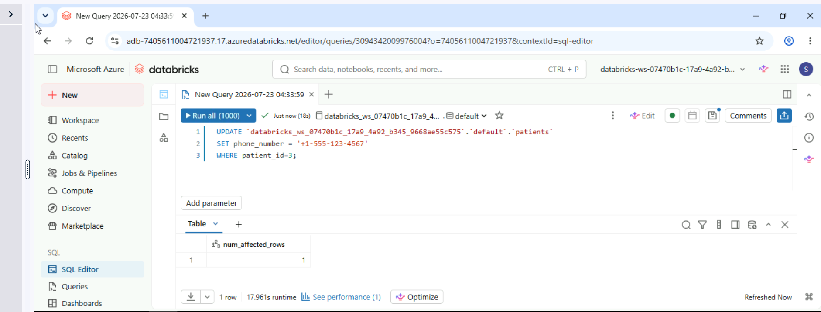
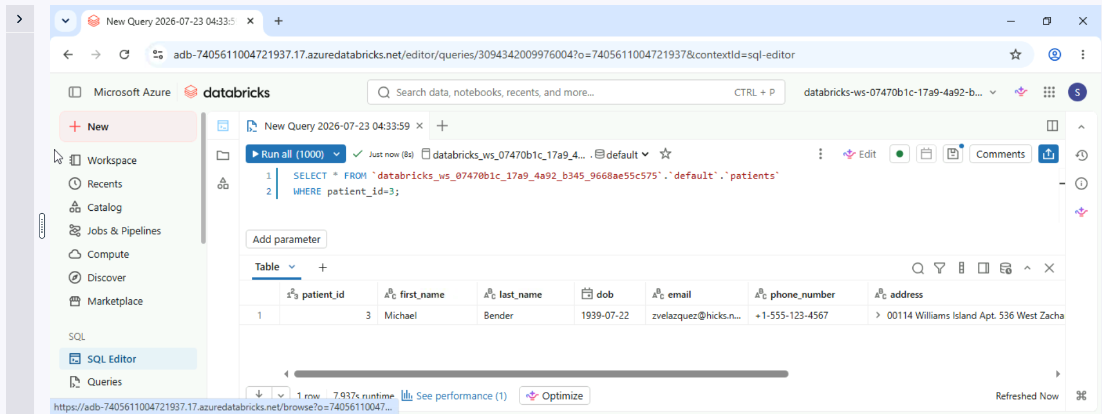

Managing data in Delta Lake
Building on your work managing patient data, you are now tasked with handling prescription data for HealthInc.
In this exercise, you will create a Delta Lake table from prescriptions.csv, delete an outdated record, and ensure all updates adhere to ACID properties for consistent data handling.
1.
- In the Catalog section locate and select the perscriptions table.
- The table is located in the following catalog and scheme:
- Catalog: Starts with databricks_ws_xxxx
- Schema: default
2.
- With the perscriptions table selected, use the dropdown menu in the top right corner of the interface, to create a new Query.
- Run a query to identify the record where the prescription_id is 1001, and the medication is "approach".

select * from `databricks_ws_07470b1c_17a9_4a92_b345_9668ae55c575`.`default`.`prescriptions`
WHERE prescription_id = 1001
AND medication = 'approach';

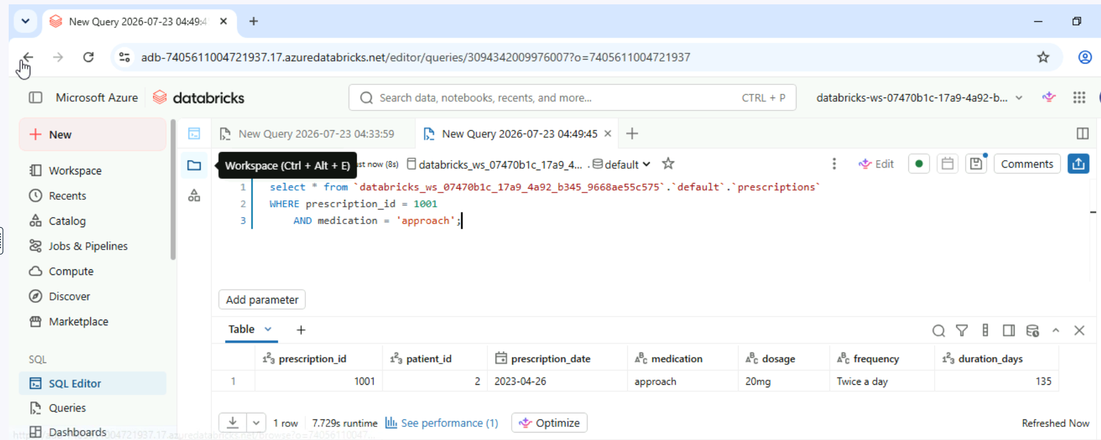

3.
The record you have located is no longer required within the table.
- Delete the record from the prescriptions table where the prescription ID is 1001, and the medication is "approach".
DELETE FROM `databricks_ws_07470b1c_17a9_4a92_b345_9668ae55c575`.`default`.`prescriptions`
WHERE prescription_id = 1001
AND medication = 'approach';
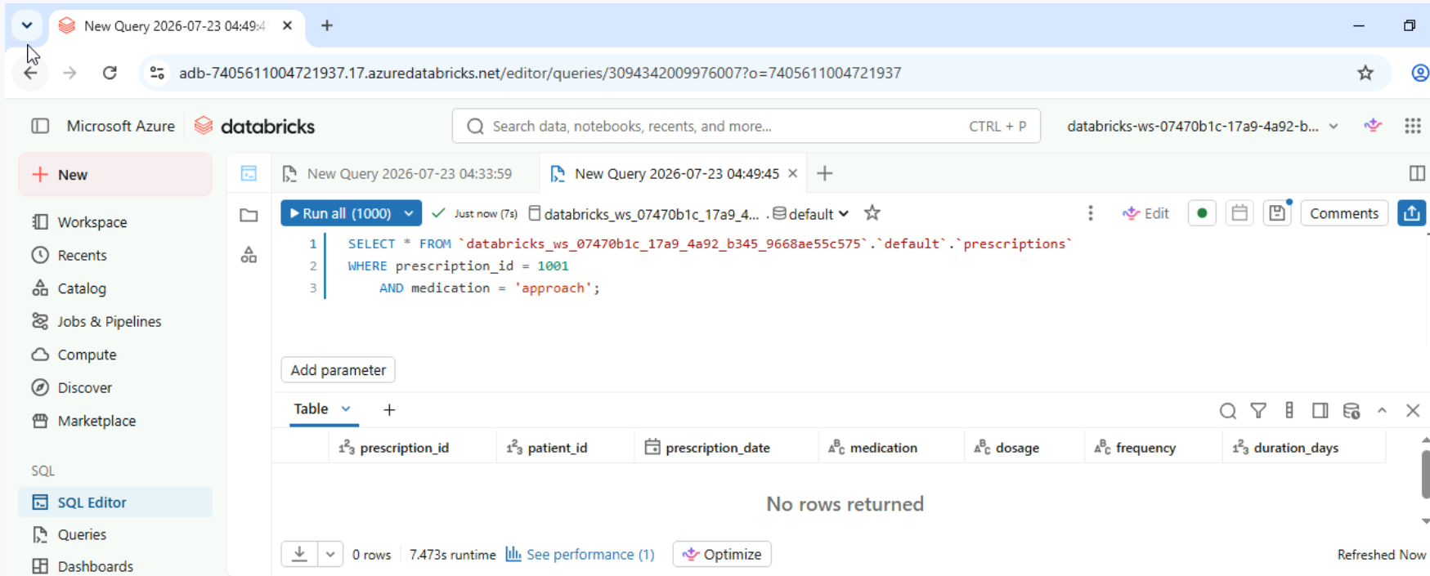

Optimizing tables
You are tasked with optimizing the appointments Delta Table. Frequent writes have resulted in the creation of many small files, which slow down query performance. In this exercise, you will use Delta Lake’s OPTIMIZE command to compact the files and verify improved query performance.
1.
In SQL Editor, run the OPTIMIZE command on the appointments Delta Table to compact small Parquet files and improve query performance.
OPTIMIZE `databricks_ws_07470b1c_17a9_4a92_b345_9668ae55c575`.`default`.`appointments`;
2.
Run the previous queries of SELECT COUNT(*) and DESCRIBE DETAIL on the appointments table to compare the query execution time and the number of small files after running the OPTIMIZE command.
Use SQL queries in the Databricks SQL Editor to validate performance improvement.

SELECT COUNT(*) FROM `databricks_ws_07470b1c_17a9_4a92_b345_9668ae55c575`.`default`.`appointments`;
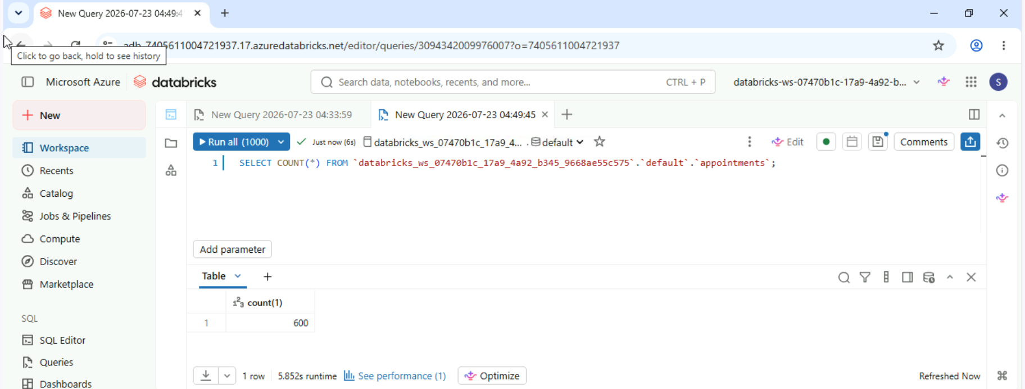
DESCRIBE DETAIL `databricks_ws_07470b1c_17a9_4a92_b345_9668ae55c575`.`default`.`appointments`;
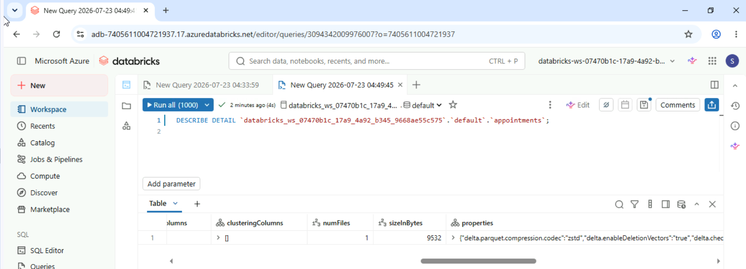

3.
After running the `OPTIMIZE` command on the `appointments` Delta Table, what is the best way to verify that query performance has improved?
R: Compare the query execution times before and after running ‘OPTIMIZE’

Deleting tables
As a data engineer, you are responsible for understanding how Databricks handles data storage for managed and unmanaged tables. Your goal is to explore the differences in data persistence when tables are created and deleted.
1.
Create a managed table named patients_managed from the existing patients Delta Table using the SQL Editor in Databricks.
CREATE TABLE patients_managed
AS SELECT * FROM patients;
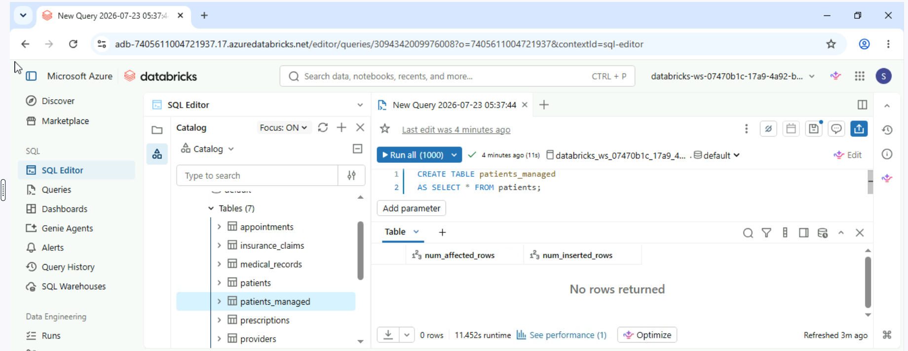
2.
Delete patients_managed table using the SQL Editor, and observe the differences in data persistence.
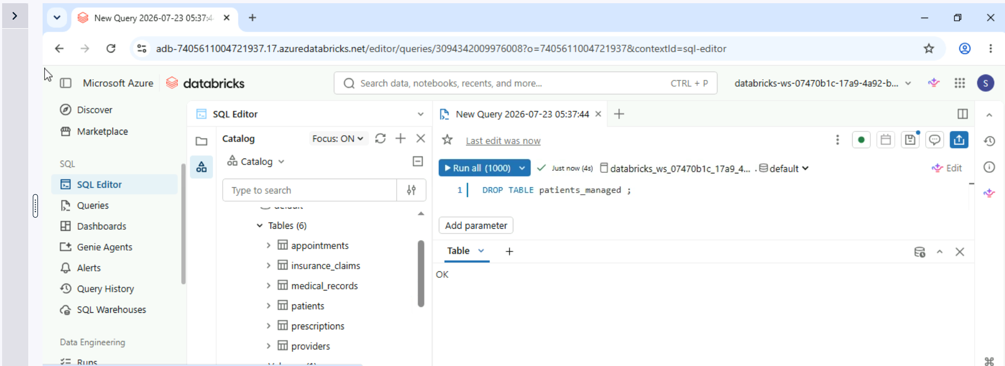
3.
What happens to the data and metadata when a managed table is dropped in Databricks?
R: Both the data and metadata associated with the table are deleted.

Chapter 2 – Running Through Views
Persist Like a Pro: Learners will practice creating and updating persistent views in Databricks using the provided datasets. This exercise will reinforce understanding of SQL commands for managing persistent views effectively.
1.
Create a persistent view called "patient_view" using the patients delta table to display all patient information.
CREATE VIEW patient_view AS
SELECT * FROM `databricks_ws_9e361810_8342_4e14_a7a7_5536200a8051`.`default`.`patients`;

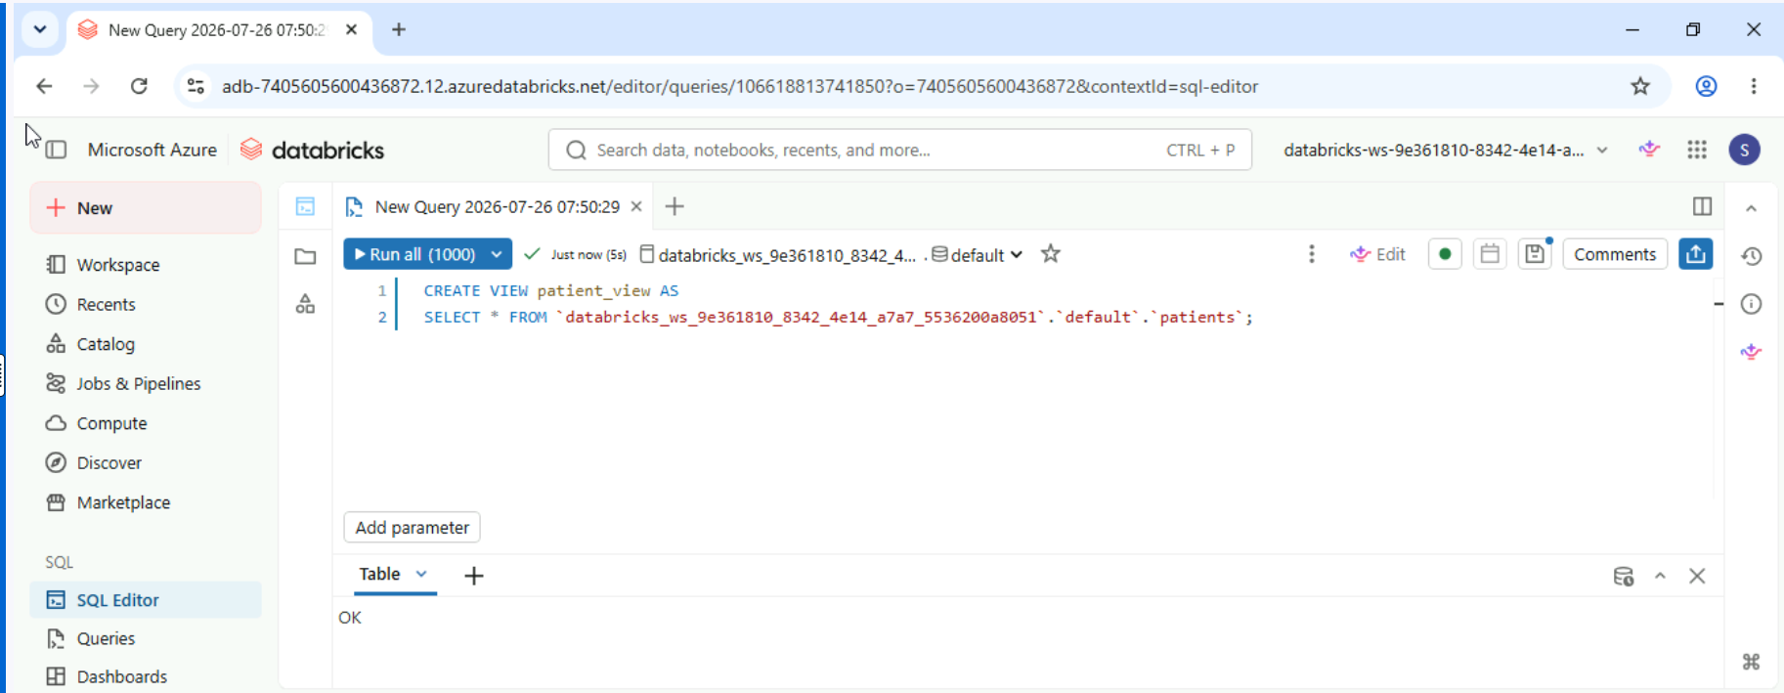

2.
Create a persistent view called "patientbloodgroup_view" that groups patients by their blood type.
CREATE VIEW patient_blood_group_view AS
SELECT blood_type, count(*) AS patient_count
FROM `databricks_ws_9e361810_8342_4e14_a7a7_5536200a8051`.`default`.`patients`
GROUP BY blood_type;

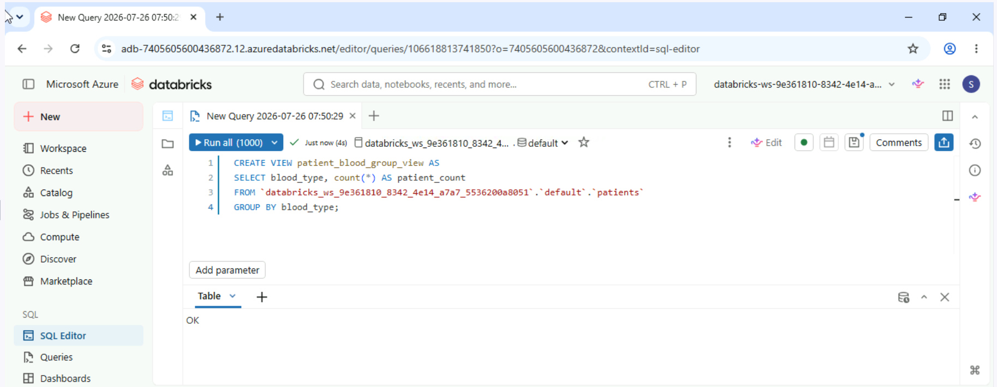

3.
Use the CREATE OR REPLACE VIEW command to update the persistent view patient_blood_group_view adding a new column to display the gender breakdown for each blood type group.
CREATE OR REPLACE VIEW patient_blood_group_view AS
SELECT gender, blood_type, count(*) AS patient_count
FROM `databricks_ws_9e361810_8342_4e14_a7a7_5536200a8051`.`default`.`patients`
GROUP BY gender, blood_type;
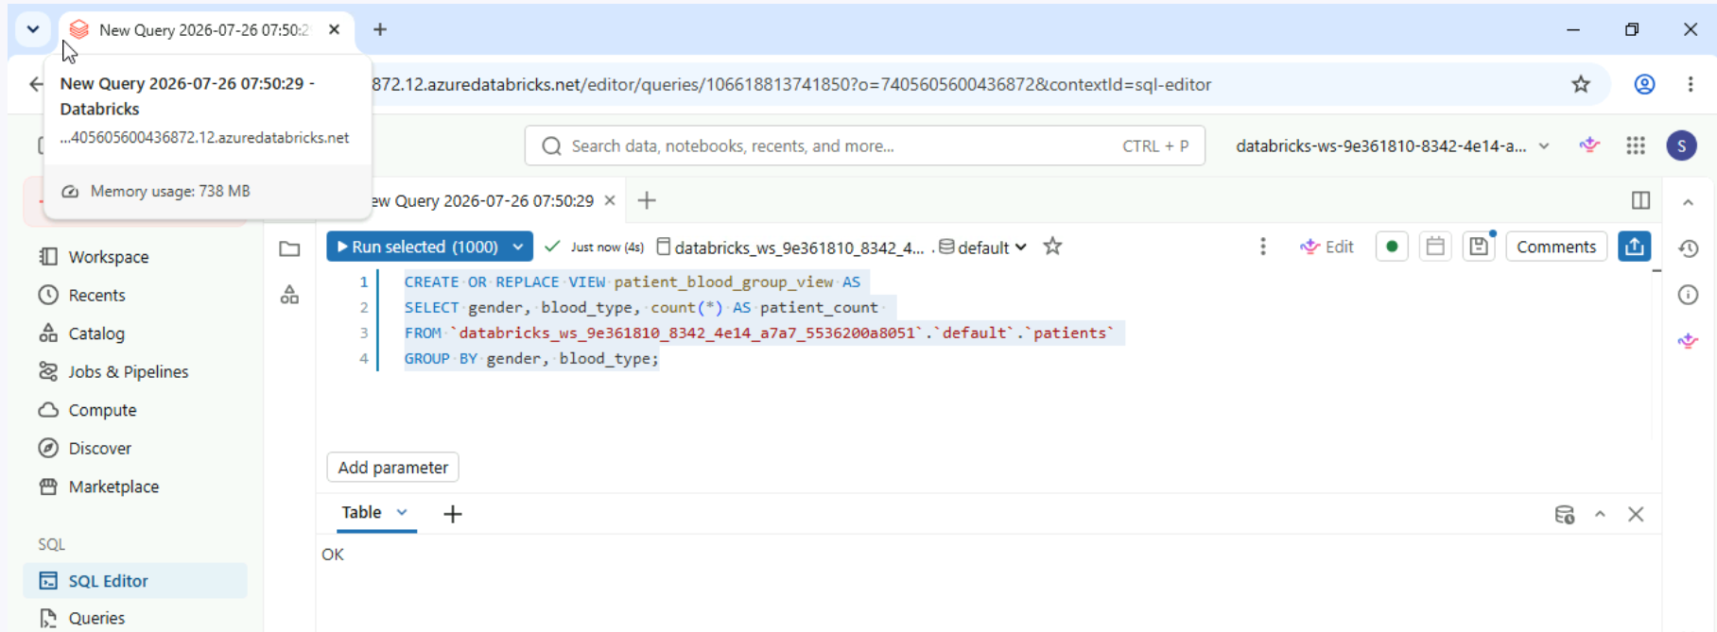

Short-lived views
This exercise focuses on temporary views in Databricks. You will create temp views in the SQL Editor and observe their behavior when the session ends.
1.
Create a temporary view called "patients_temp" in the SQL Editor that filters the patients table to include only patients born in or after 1980.
CREATE OR REPLACE TEMP VIEW patients_temp AS
SELECT *
FROM `databricks_ws_9e361810_8342_4e14_a7a7_5536200a8051`.`default`.`patients`
WHERE dob >= '1980'
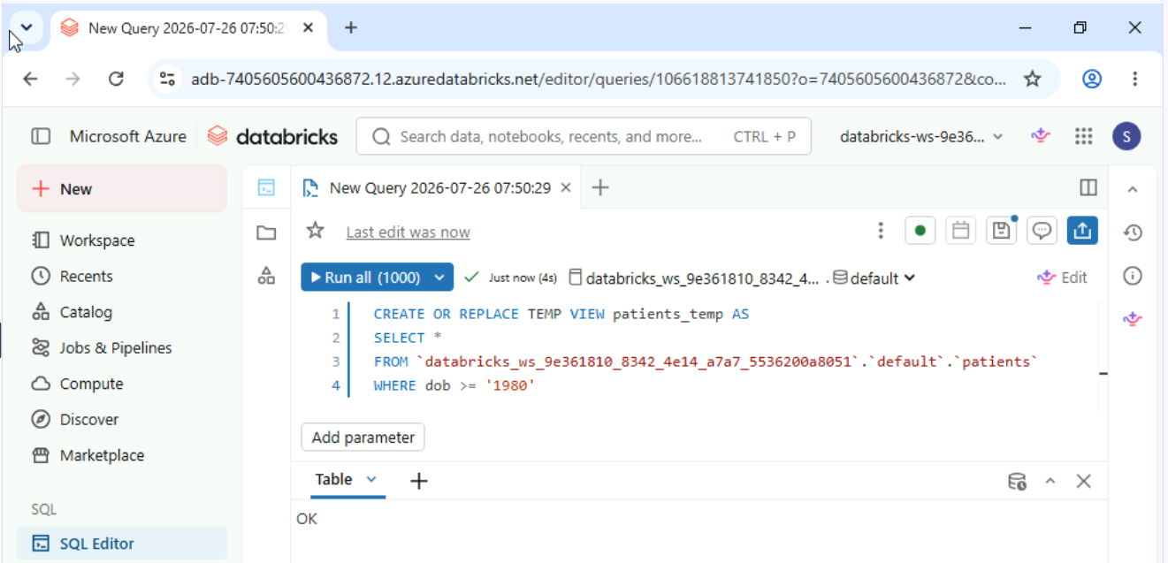

2
Disconnect and reconnect to the SQL Editor to simulate a new session.
After reconnecting, attempt to query the patients_temp view to observe its behavior after the session ends.
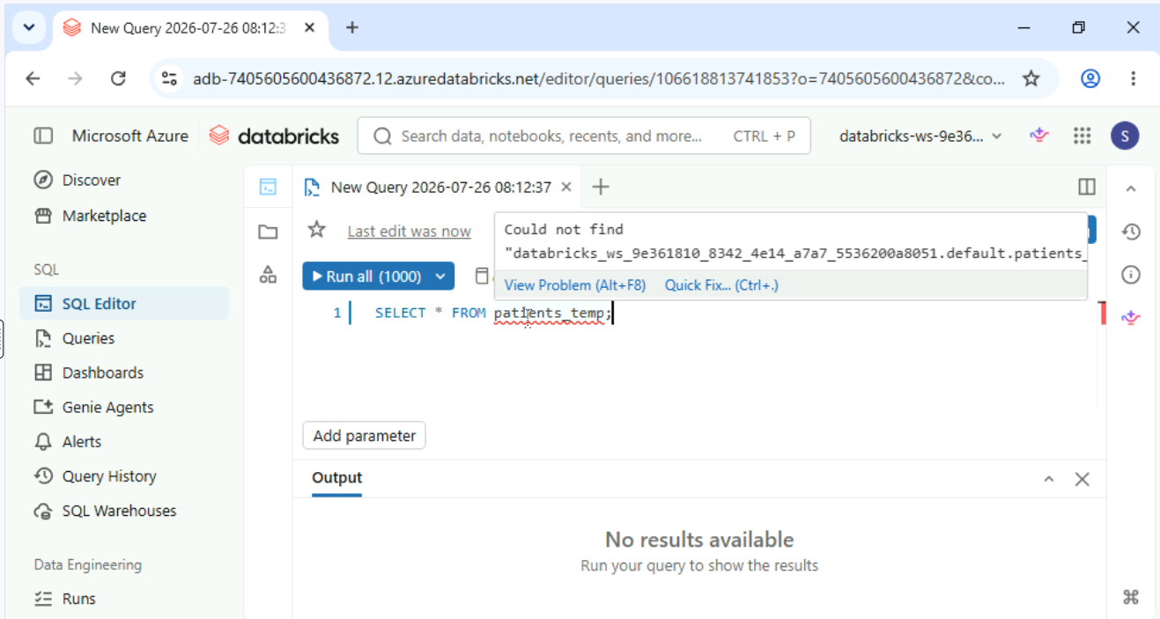

Persistent view magic
Persistent views remain available across sessions but do not automatically refresh when the underlying table is updated.
In this exercise, you will explore how persistent views in Databricks work about the underlying data and how to manually refresh data in a persistent view to ensure your queries return the most up-to-date results.
1.
Create a persistent view named active_patients_view in the SQL Editor that filters the patients table for patients born after 1980.

CREATE OR REPLACE VIEW active_patients_view AS
SELECT *
FROM `databricks_ws_9e361810_8342_4e14_a7a7_5536200a8051`.`default`.`patients`
WHERE dob > '1980';

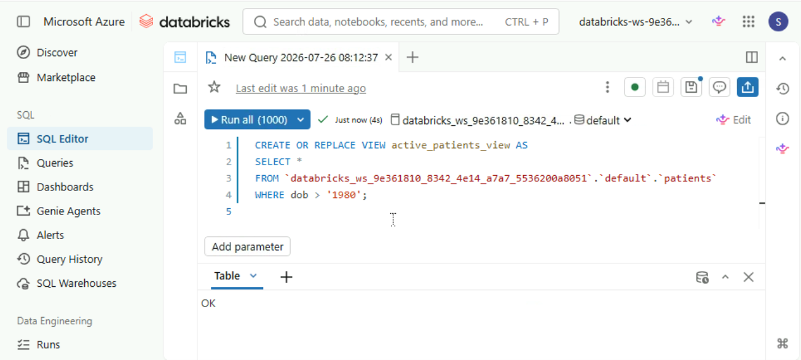

2.
Verify the creation of active_patients_view by listing all views in the database using the SHOW VIEWS command.
Show views;
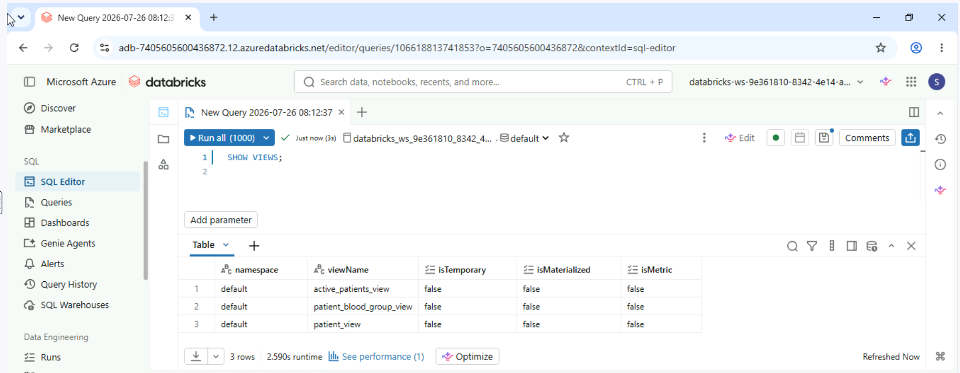

3.
Disconnect and reconnect to the SQL Editor to simulate a new session. Query the active_patients_view to confirm that it persists across sessions.
SELECT * FROM active_patients_view;
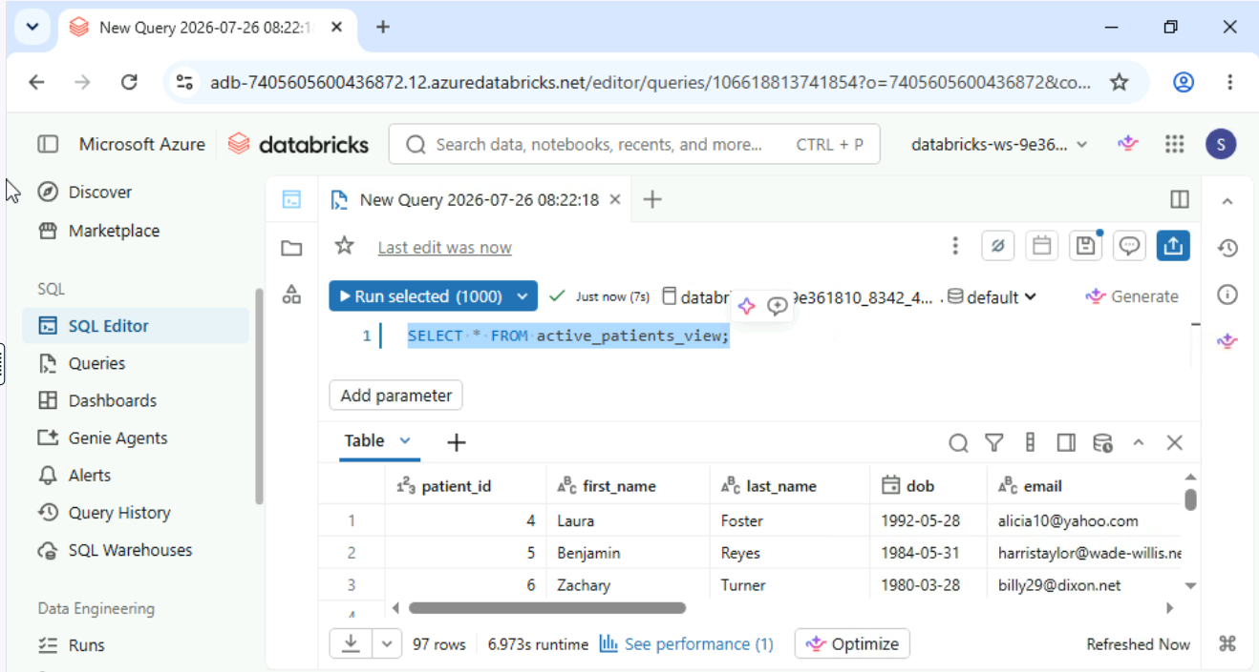

4.
Drop the active_patients_view using the DROP VIEW command to free up space and maintain a clean database structure.
DROP VIEW active_patients_view;
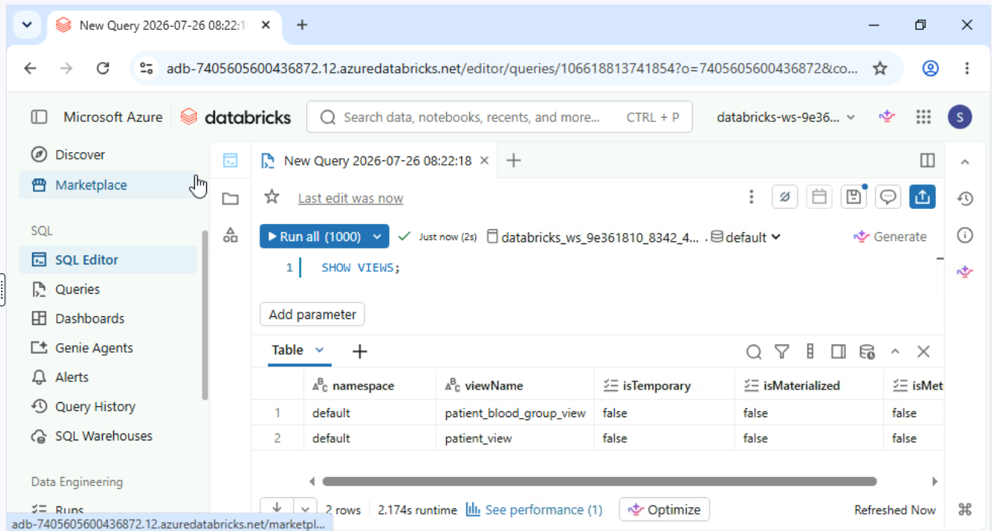

Chapter 2 – Data Exploration and security
Exploring datasets
This exercise introduces Databricks Data Explorer, a tool for exploring datasets, previewing data, and managing access controls.
You will navigate to tables, preview data, and configure access permissions to ensure security and governance. But first, you have to load a CSV file into your schema
  - Navigate to the Data Ingestion section using the menu on the left-hand side of the UI. Click on Create or modify table, and then on browse in order to open a new pop-up window. Navigate to the Desktop folder, then click on Datasets. Select the CSV file called patients.csv and then click Open.

  - Make sure to rename the new table "patients_new". you will see a preview of your data, as well as options to select your catalog and schema of choice. Make sure that the following settings are selected at the top of the page.
  - Catalog: Starts with databricks_ws_xxxx
  - Schema: default

  - Open Data Explorer in Databricks and navigate to your tables.
  - Within Data Explorer, navigate to the tables section and preview the patients_new Delta table to inspect its content.
  - Grant "SELECT" permissions to the patients_new Delta table for All account users via the Permissions tab in Data Explorer.
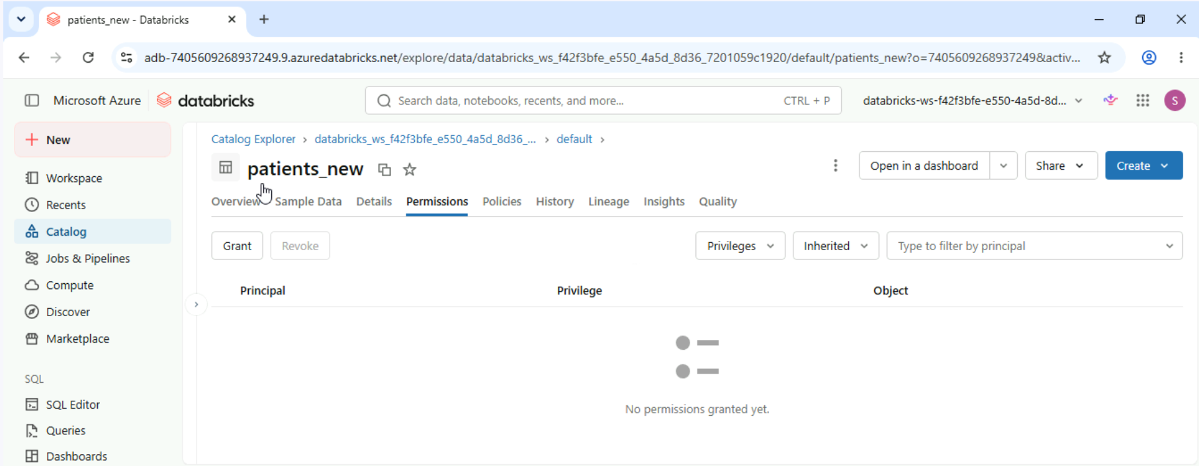
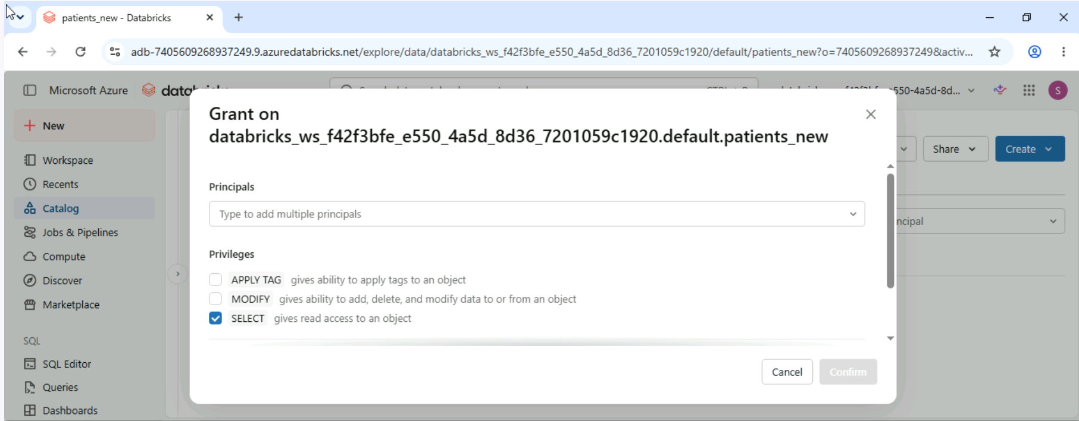

Logs and security
Monitoring data usage is a critical responsibility for table owners to ensure compliance with governance policies and detect potential security risks. This exercise guides you through accessing usage logs, identifying anomalies, and taking appropriate actions to secure sensitive data.
- Navigate to the appointments table in Data Explorer.
- Open the History tab for the appointments table to review recent activity and understand access patterns. In the first box you can select all users to see all users actions or your account to see your actions.
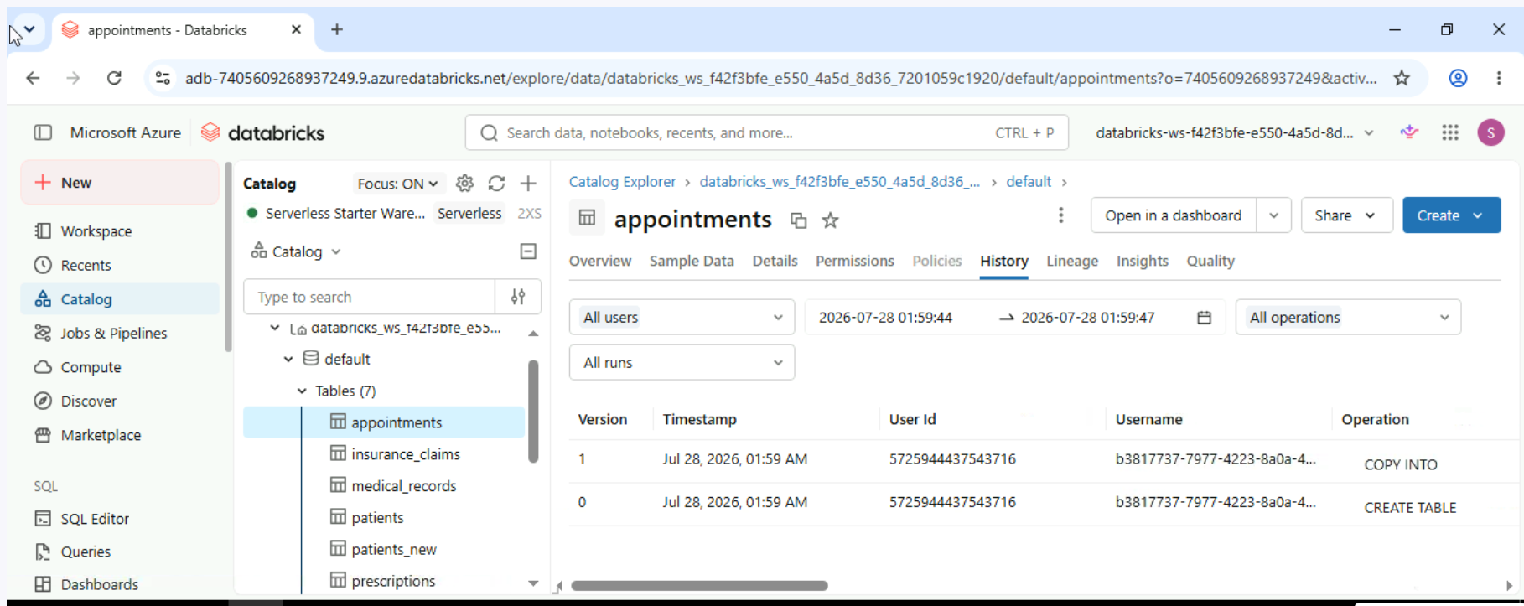
- Analyze the activity logs for anomalies, such as unusual access times or excessive queries, if present.
Protecting patient names
In this scenario, you're working with sensitive healthcare data, such as patient names and insurance information. Protecting this data using proper access controls is critical to comply with data privacy standards and ensure security.
- Preview the patients_new table by running a query to verify that the essential fields, such as patient_id, first_name, and insurance_id, are correctly populated.
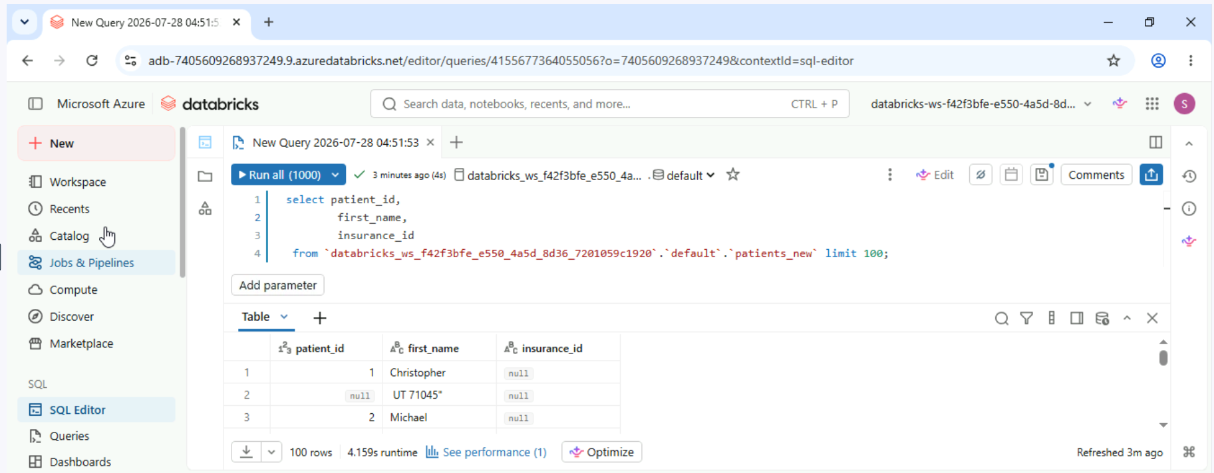

- Run a query on the medical_records table to verify fields such as diagnosis, treatment_cost, and patient_id are correctly structured for linking with the patients_new table.
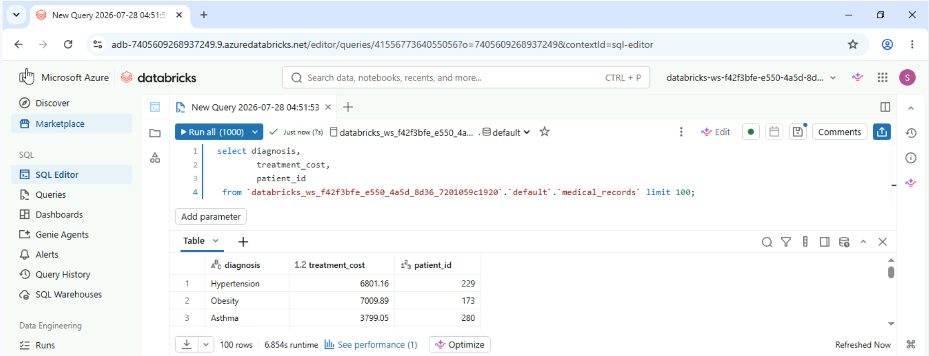
- Revoke "SELECT" permissions to the patients_new Delta table for All account users via the Permissions tab in Data Explorer. You can use revoke access to ensure only users who require access can access sensitive patient data.
